YOGASANAS - IN SUPINE POSITION
UTTANPADASANA – DWIPADA (BOTH LEGS)
Introduction :
In this asana both the legs (Dwipada) are raised upward and that is why it is called ‘Dwipada Uttanpadasan.’ It is also the first stage of Sarvangasana & Viparitakarni. Because it has its own advantages as an asana, it is practiced independently.
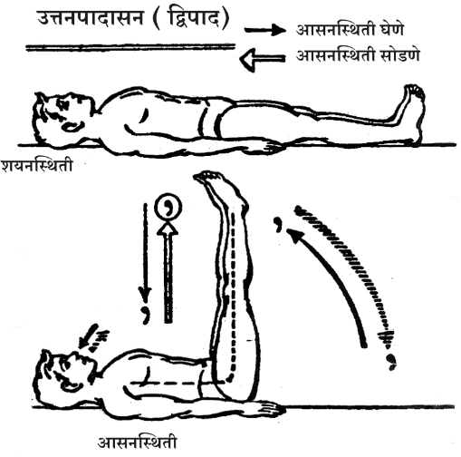

Taking The Asana Position :
Initial Position : Supine Position.
1) Exhale, then inhaling, start raising both the legs upward slowly and stabilize them when they reach 90 degrees from the floor. Keep the sight at the toes of the feet and the breathing normal.
The Asana Position :
While raising the legs upward, it is necessary to keep both the legs close to each other and straight in the knees. Then, keep the back and the shoulders relaxed but flat on the floor when the legs are fixed at 90 degrees. Keep the toes of the feet together and stretched towards the sky. The muscles of the thighs and the calves remain strained, but an attempt should be made to relax the muscles of the shoulders and the abdomen.

Releasing The Asana Position :
1) Inhale, then exhaling, bring both the legs down slowly at ease. Finally get them to the floor and back to the supine position.
Duration :
This asana appears to be simple and very often people take the position successfully. But it is difficult to maintain. In the beginning, it can not be maintained even for five seconds. The muscles of the thighs and the feet start trembling. On such occasions the asana should be released immediately and it should be practiced through repetitions. It is expected to maintain the asana for at least thirty seconds to get the benefits. With more practice, it can be maintained up to five and then up to ten minutes.
Internal Effects :
In this asana the muscles of the thighs and the stomach are desirably stretched. This pressure on the small and large intestines, enzyme producing glands and other internal organs activates them and makes them more efficient. Further the vertical position of the legs helps the impure blood flow towards the heart to be re-circulated, because of the gravitational pull.
Precautions :
While doing this asana, raising or bringing down the legs very fast or with jerks should strictly be avoided. The movements should be controlled and at ease, or the concerned muscles may be strained and the asana may do more harm than good.

EKPADA UTTANPADASANA (WITH ONE LEG)
Introduction:
In this asana only one leg is raised up at a time and therefore, it is called ‘Ekpada (one leg) Uttanpadasana.’ There is more strain in this asana than in Dwipada (both legs) Uttanpadasana. Therefore, this asana should be done after enough practice of Dwipada Uttanpadasana.
Taking the Asana Position :
Initial Position : Supine Position.
1) Exhale and inhaling start raising the left leg without allowing it to bend in the knee and stabilize it at 90 degrees from the floor. Keep the breathing slow and smooth, the sight should be fixed at the toes of the raised feet. Don't move the right leg; keep it firm on the floor.
The Asana Position :
In this Asana the raised leg should be kept straight and its toe stretched upward; at the same time, the leg on the floor should be kept relaxed and firm to the floor. This position enables the body to have the xpected strain. During the stability period of the Asana, sometimes there is possibility of trembling. But this disappears with practice. The final position devoid of tremor is the ideal position of this Asana.
Releasing The Asana Position :
1) Inhale and exhaling start bringing the leg down at ease & place it on the floor, and take the supine position.
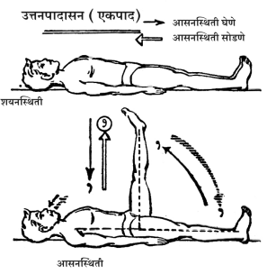
NOTE : Now raise the right leg & do the Asana as mentioned above.
Duration :
Initially it is difficult to maintain it for a long time because the strain causes tremor. Therefore, one should repeat the Asana, three to four times and later increase the duration of the Asana. This can be maintained up to three minutes.
Internal Effects :
In this Asana one leg is raised while the other one remains on the floor. This position causes mutually opposing strain in the legs and has a favourable effect on the concerned muscles.
Precautions :
The same as stated for Dwipada Uttanpadasana.

VIPARIT KARANI
Introduction :
"Hathapradipika', an important book on Hatha Yoga, treats
Viparit Karani as a Mudra rather than an Asana. But since this very much resembles an Asana, the attempt here is to treat it as an Asana. In this Asana the body takes an inverted position and therefore it is called ‘Viparit Karani.’
Taking The Asana Position :
Initial Position : Supine Position
1) Exhale, then inhaling, start raising both the legs upward and get into the position of Dwipada Uttanpadasan
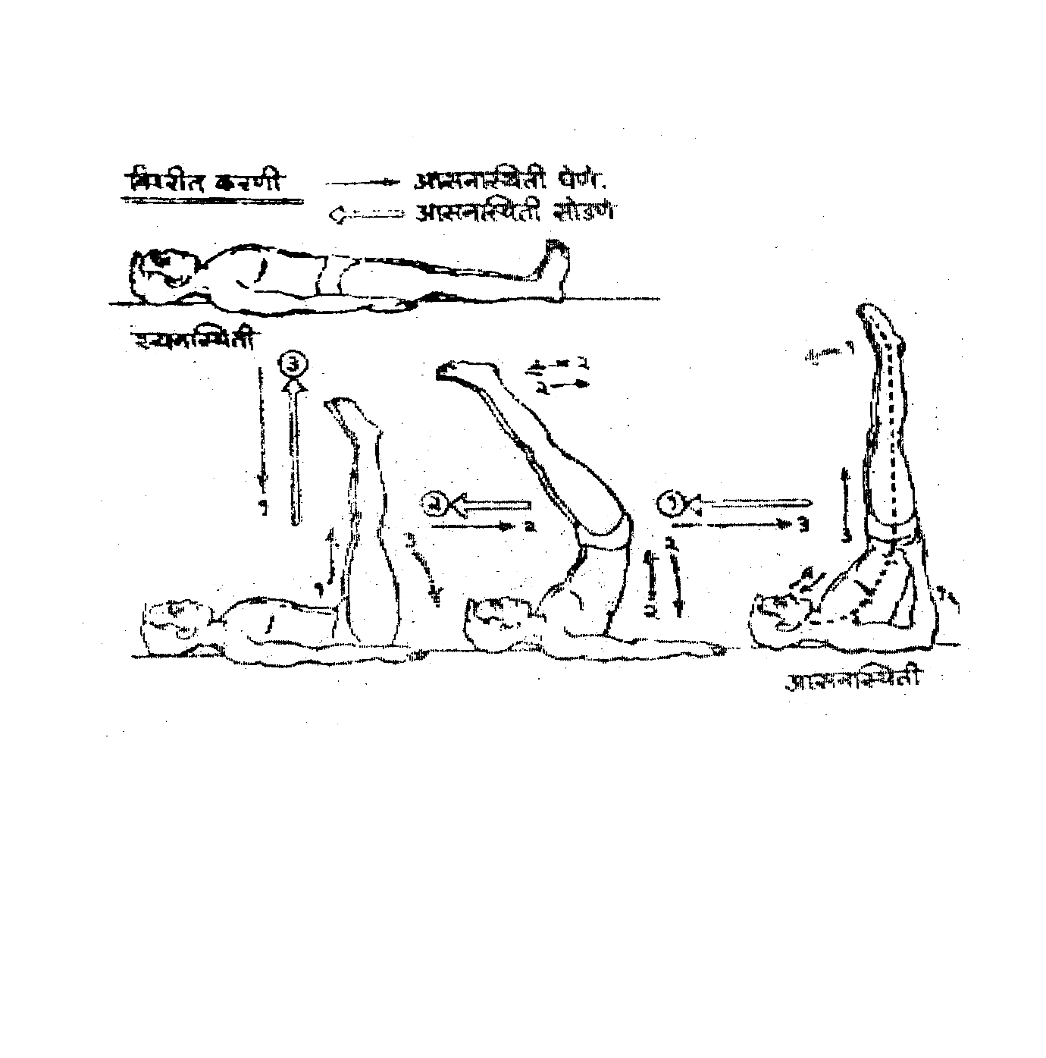
2) Exhaling at ease raise the waist and push the legs backward over the head, using the hands to stabilize the body.
3) Inhaling, place both the hands below the waist, near the hips, and straighten the legs, stretch the toes upward, fix the sight on the toes of the feet, and keep the breathing normal
The Asana Position :
In this asana the upper arms, from the shoulders up to the elbows, are placed on the floor and the forearms are kept straight with the hands below the waist to support it. The body from neck to the elbows is kept straight alignment. The toes should stretch upward, towards the sky with the sight fixed on the toes. In this Asana the neck is completely free and the back is in a slanting position, ideally at a 45 degree angle from the floor. Initially it becomes difficult to maintain this asana keeping the legs straight. Therefore the legs can slightly be lowered toward the head which helps in keeping the balance. After constant practice and efforts, the ideal position can be reached and even maintained.
Releasing The Asana Position :
1) Inhale and exhaling slightly lower the legs towards the head; maintain the balance of the legs. Bring the hands on the floor & take the position No.2 mentioned above.
2) Inhaling, place the waist on the ground & keeping both the legs straight take Dwipada Uttanpadasana position.
3) Exhaling start getting both the legs down slowly and place them on the floor and take the supine position.
Duration :
Performing this asana is difficult in the beginning and particularly it is more difficult for women with heavy hips and men with big bellies. Initially one can take help from others for lifting the hips and waist. However, after a little practice, the whole process becomes easy. It should be maintained for two to three minutes to get the desired benefits. Further the duration can be increased to six minutes.
Internal Effects :
In our daily life, most of the time, we remain either in standing or sitting positions. Quite the opposite occurs in this asana. This inverted position helps the impure blood of the lower part of the body to flow towards the heart due to the gravitational pull. Further, the muscles of the raised legs should be kept relaxed or else there is the possibility of tingling in soles and calves as the blood circulation does not reach there, because of the reverse position. To some extent all the advantages of Sarvangasana and Shirshasana are experienced in this asana.
Precautions :
This asana should not be performed by any persons suffering from heart trouble and blood pressure. However, it can be performed under the supervision and guidance of a yoga expert and doctors. The asana should be released the moment there is trembling or tingling in the legs.
SARVANGASANA
Introduction:
This is the developed stage of Viparit Karani. There are innumerable asanas in yoga; out of them all, only eight or ten are mentioned as very important ones. Sarvangasana is considered to be the best among those mentioned Asanas. This Asana activates & invigorates all the important glands of the body, and therefore this asana is called Sarvangasana. Even old books concerning yoga Shastras make special mention of this asana.

Taking The Asana Position :
Initial Position : Supine Position
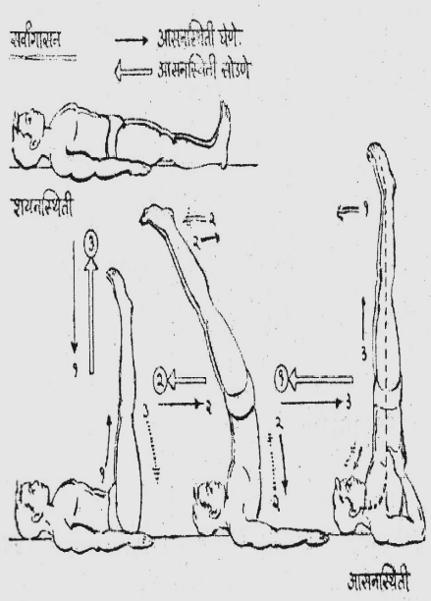
1) Exhale and inhaling, start raising both the legs and bring them to 90 degree angle from the floor and take Dwipada Uttanpadasana position.
2) Exhaling, raise the waist and hips and take the legs backwards and above the head.
3) Inhaling, raise the back and the legs up into vertical posture; bring the trunk and both legs in one vertical straight line. Further, place both the palms at the back and with the help of their support get the legs, the waist and the back in one straight line and stabilize them in this position. Fix the sight on the toes of the feet and keep the breathing normal.

The Asana Position :
In this asana one should first get the legs, the waist and the back in one straight line and then keep them in 90 degree angle from the ground. This makes the whole body, right from the feet to shoulders straight, only the neck remains curved and the chin is placed in the jugular notch forming a tie/lock which is called ‘JALANDHAR BANDHA.’ Because of this Bandha the jaws cannot be opened. Having this Bandha in this asana is very essential. In the earlier stages of practicing this asana, the back ribs should be supported by the palms of the hands. But after sufficient practice, this asana can be performed without this support, though that is a highly developed stage.
Releasing The Asana Position :
1) Inhale and exhaling, bend in the waist and take the legs back over the head and remove the palms supporting the back and place both the hands on the floor.
2) Inhaling, slowly bring the back to the floor and keep the legs at 90 degree angle from the ground, in Dwipada Uttanpadasana.
3) Exhaling bring both the legs slowly down and place them on the floor. Take the supine Position.
Duration :
Only those who can perform this asana successfully will maintain it for a longer time. For others it will be difficult to maintain even for a very short time. After adequate practice, it can be maintained for half an hour. But this should be done only when this asana alone is practiced independently. Otherwise in normal conditions it should be maintained for minimum three minutes to get the expected benefits. In daily practice it can be maintained for six minutes without any harm.
Internal Effects :
In this asana one gets all the advantages of Viparit Karani. Additionally, the Jalandhar Bandha is formed which brings pressure particularly on the thyroid glands and to some extent on the pituitary glands, activating and invigorating them. The health of the human body is greatly controlled by these very important glands. This asana regulates and cures the troubles relating to the above mentioned glands and also the genital organs and constipation. It also prevents and cures varicose veins and hemorrhoids.
Precautions:
Persons suffering from headache, brain diseases, blood pressure etc., should perform this asana only under the guidance of a yoga experts. If a person wants to maintain the asana for more than five to six minutes, he should do so after consulting a yoga expert.
NOTE : Since in this asana the Jalandhar Bandha is formed it becomes necessary to practice ‘Matsya Bandha’ after Sarvangasana. Therefore, it should be followed by MATSYASANA and held for 1/3rd the time duration of Sarvangasana.
ASHWINI MUDRA

Introduction:
"Ashwa' means horse. In the way a horse contracts and expands its anus after releasing the waste matter, a similar contraction - expansion process of the anus is expected in this asana. Now in order to do this process, some specific position of the body is necessary. This required position is obtained in ‘ASHWINI MUDRA.’
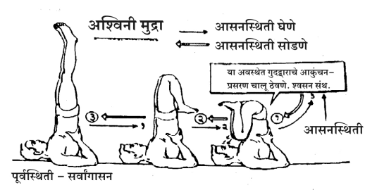
Taking The Asana Position:
Initial Position : Sarvangasana Position
1) From Sarvangasana, bend both the legs in the knees.
2) Fold down and press the thighs against the stomach.
3) Contract and expand the anus in this position. Besides, keep the breathing normal.

The Asana Position:
The process of performing this Mudra should start when the body stabilizes in Sarvangasana. In this position the complete folding of legs and knees into waist is very important. The calves should touch the hamstrings and the thighs touch the abdomen. During this period the neck & the back should not become loose. The back should be completely erect and perpendicular from the floor. If the back curves, then knees come close to the mouth and that is not desirable. Both the legs, toes, heels should be kept close together.
Releasing The Asana Position :
1) Stop contraction- expansion of the anus.
2) Lift the legs out of the waist, unfolding the knees.
3) Straighten the legs and come to Sarvangasana position.
Duration :
It should be maintained for 45 seconds, and can be increased to two minutes.
Internal Effects :
This mudra has particularly good effect on the empty spaces in the stomach. They take an inverted position and get pressure from all sides. As a result of this their functioning is improved. It also has good effect on the uterus located in the abdomen of women.
Precautions :
Any normal man or woman can practice this mudra. But women having any uterus problem and wish to practice it as treatment should consult a yoga expert.
MATSYASANA
Introduction :
There are asanas which have taken their names from the shapes of relevant animals. In this posture, the shape of the body appears like a fish and therefore it is called ‘Matsyasana.’ Such a statement would be a daring one as the fact is that in this Asana one does not look like a fish. However, while swimming one can have this fish like position and float on the surface of water without any movement. And for this action it must have been given the present name.

Taking The Asana Position :
Initial Position : Supine Position
1) Spread the legs apart at a distance of one foot.
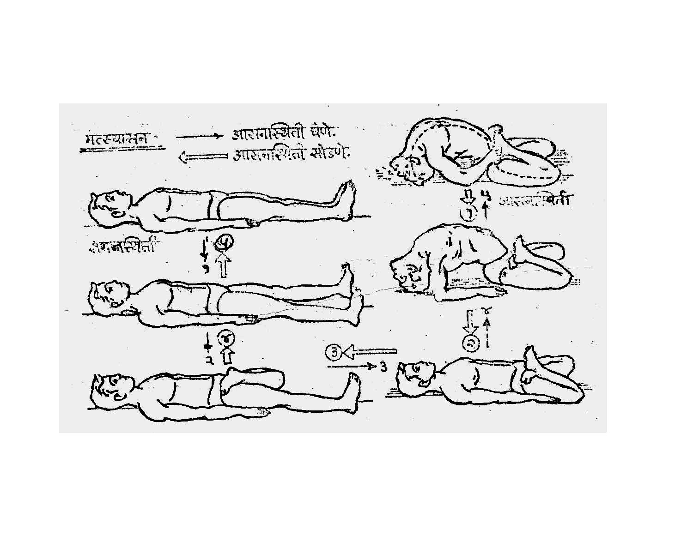
2) Fold the left leg in the knee and place it on the right thigh.
3) Fold the right leg in the knee and place it on the left thigh.
4) Now raise the head with the help of the elbows, curve the neck backward and place the top of the head on the floor, making an arch of the back.
5) Hold the toes of the feet with the hands & continue normal breathing.
The Asana Position:
In this asana the thighs and knees of both the legs are completely placed on the floor. The general observation is that the moment the shoulders are raised to the back, the knees also get raised at the front. However, the knees should be firmly rest on the floor. Further when the back is raised and the head rests on the floor, it creates an arch of the back and most of the weight shifts to the head and the throat is stretched and this position is desirable. It has been said that the toes of the feet are held by the hands, i.e., right toe by the left hand and vice versa. But after considerable practice, it becomes possible to hold the right toe by the right hand and the left toe by the left hand.
Releasing The Asana Position :
1) Release the toes of the feet and support the shoulders with the elbows.
2) Slowly reducing the weight over the head, straighten the neck and bring the shoulders on the floor.
3) Straighten the right leg.
4) Straighten the left leg.
5) Bring both the legs together and take Supine Position.
Duration :
This asana is complementary to Sarvangasana. It should be maintained for one-third to half of the period of Sarvangasana.

Internal Effects:
Jalandhar Bandha in Sarvangasan brings pressure onto the thyroid and parathyroid glands, while the Matsya Bandha in this asana stretches them. These opposite processes improve the circulation in the organs situated in the throat and contribute to the healthy functioning of the glands. Besides, the cells of the thighs and the muscles of abdomen are systematically stretched and their functioning is improved. The position of the head helps supply the blood to the brain.
Precautions :
The weight over the head should be taken out slowly. The support of the hands should be removed only when the head is prepared to bear the weight. Besides, there should not be any haste while leaving the asana. The haste might cause sprain to the neck muscles. Maintain the asana only until it is bearable and pleasant.
HALASANA

Introduction :
The shape of the body in this asana looks like a plow (hala) and therefore, it is called Halasan. Just as plowing makes the hard ground soft and makes it fit for sowing, similarly the veins of the body get stretched in this asana and the body's stiffness is greatly reduced.

Taking The Asana Position:
Initial Position : Supine Position
1) Exhale and inhaling, start raising the legs and bring them to 90 degrees from the floor and take Dwipada Uttanpadasana position.
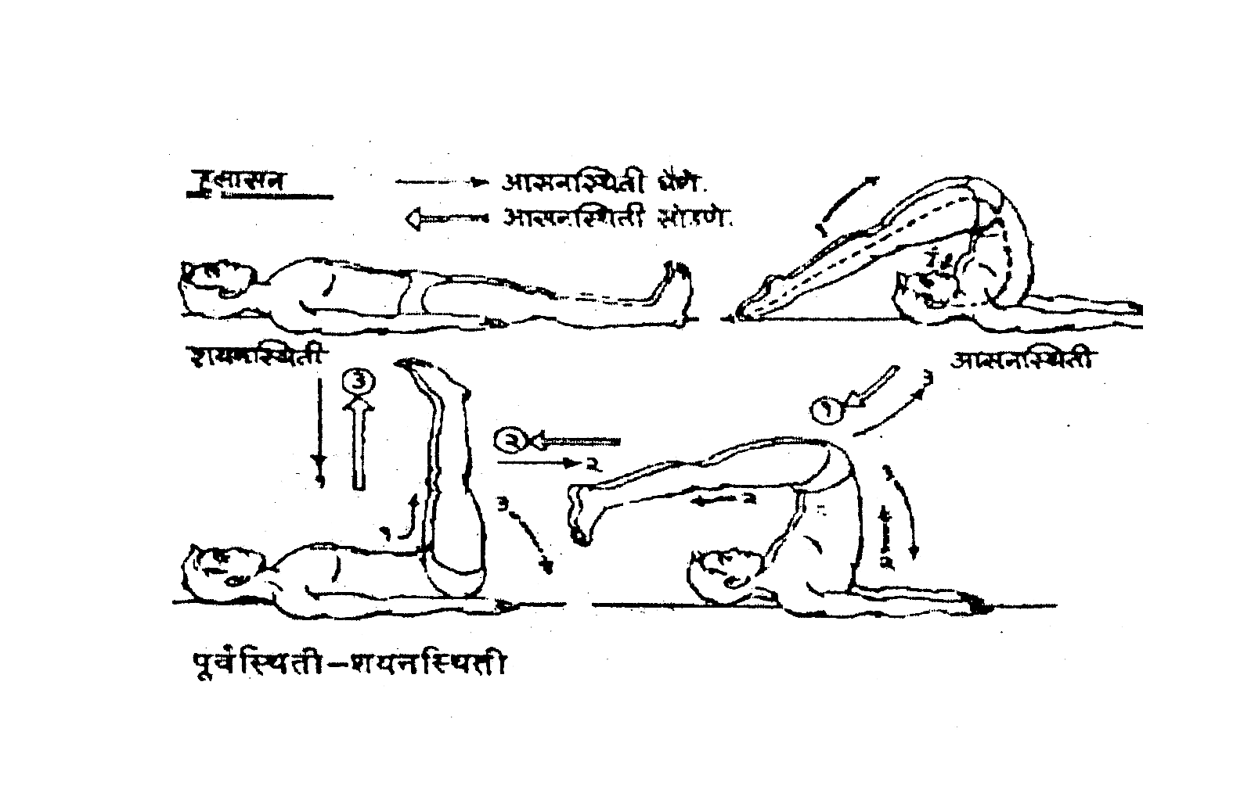
2) Exhaling, raise the waist, and hips and take the legs back over the head and keep them suspended in that position and maintain the balance.
3) After exhaling fully, push the legs further back down and rest the toes of the feet on to the floor. Keep the toes stretched and breathing normal.
The Asana Position :
While the feet rest back on the floor, the toes are kept stretched and placed away from the head. That is, touch the nails of the toes on the floor. Also, keep the knees straight or else the expected pressure on the desired organs will not take place. The arms should be retained in the earlier position, i.e. they should remain close to the floor. In this position the head, the shoulders, toes and arms, should be resting on the floor. The chin being pressed to the chest, strong Jalandhar Bandha is formed. There are some variations in this asana regarding the position of the hands, viz, some advise holding the thumbs of the feet with the hands, while others keep the hands below the neck.
Releasing The Asana Position :
1) Exhale and inhaling lift the toes up from the floor and keep the legs straight in the knees.
2) Continue inhaling and slowly place the spine on to the floor and take Dwipada Uttanpadasana.
3) Exhaling, start bringing the legs down and place them on the floor and take Supine Position.

Duration :
Initially to take this asana position is relatively difficult. Therefore, one should initially pay full attention to its successful performance. In the beginning it is advisable to perform four to five repetitions of this asana of five to ten seconds each. Normally one gets the desired results by maintaining it for thirty seconds; with more efforts it becomes possible to increase its duration to three minutes.
Internal Effects :
In this asana the spine is fully curved. Therefore, the whole spine gets effectively stretched. Consequently, it becomes highly elastic and its overall functioning is greatly improved. Like Sarvangasana, here also the Jalandhar Bandha is formed and naturally one receives its advantages. All the muscles from the waist to the toes are nicely stretched. As a result, all the concerned veins get purified. This asana is also very effective on gastric complaints. It improves the function of the muscles and the organs of the abdomen. It also helps to improve complaints regarding digestion problems.
Precautions :
There is tremendous strain on the spine in this asana. Therefore, it should be performed slowly and at ease. If the legs are pushed back with a jerk or in haste, it might cause some injury to the backbone. It is necessary to prepare the spine for the expected strain. The movements at each stage should be highly controlled and gradual. There should be no haste for attaining the ideal final position. People suffering from spleen and liver complaints should perform the asana only after consulting some yoga expert.

NOUKASANA
Introduction :
We have already seen Noukasana in Prone Position. Here we are going to see this asana in supine position. In this asana the shape of the body looks like a boat and hence the name Noukasana. Here the muscles of the stomach and abdomen get contracted, while in the earlier one they get expanded. Thus, the two asanas have the same name, but both greatly differ in their positions and effects.
Taking The Asana Position :
Initial Position : Supine Position
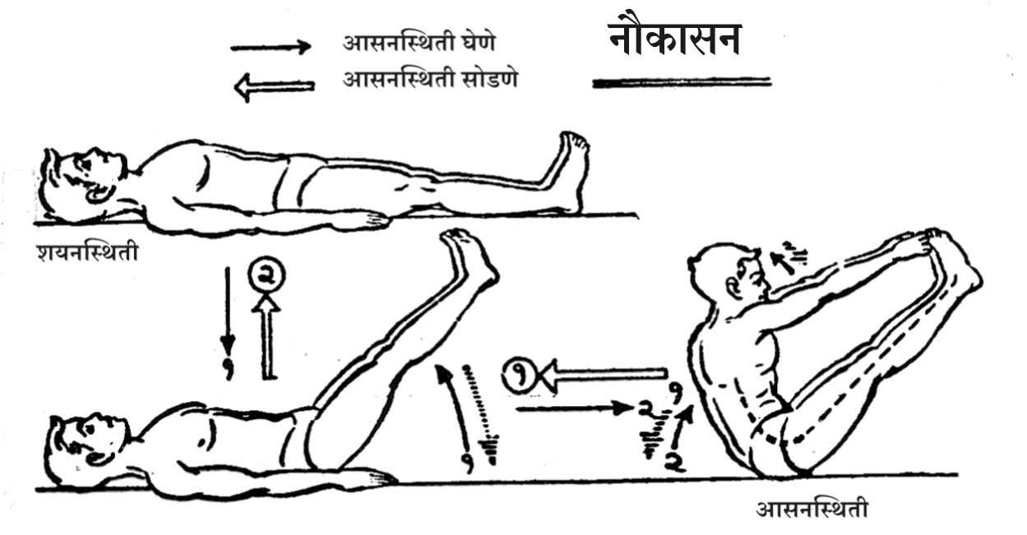
1) Exhale and inhaling start raising both the legs slowly and stabilize them at 45 degree angle from the floor.
2) Hold the breath and in the same position raise the shoulders and the back, and hold the toes of the raised legs with both the hands. Now maintain the position and continue normal breathing.

The Asana Position :
It is very necessary to keep the legs straight in the knees. The desired pressure is lost, if the legs bend in the knees. Carefully maintain the balance of the body as this asana is difficult in the beginning. If one cannot hold the toes initially, then he should try to hold the legs at the ankles, of course without bending the legs in the knees. The constant and careful efforts enable the person to attain the ideal position.

Releasing The Asana Position :
1) Inhale and exhaling, release the toes and place the hands, the back, and the head on the floor.
2) Continue exhaling and bring the legs down slowly, place them on the ground, and take the Supine Position.

Duration :
Initially one should maintain this only for a few seconds as it involves strain and needs balancing, and hence, cannot be retained longer. After practice, it should be kept for fifteen seconds to get the desired benefits.

Internal Effects :
The contraction of abdominal muscles is of great importance in this asana. Besides, the size of the belly reduces as it gets folded from both the sides. Consequently there is pressure on intestines, liver, pancreas, kidney etc., and their functioning is greatly improved. This Asana is recommended for those who suffer from the troubles of hernia & kidney.

Precautions :
It is said that this asana cures the diseases of the belly, but one should not try it on his own. He should consult some yoga expert. Those operated on the abdomen should probably avoid this asana.

PAVANMUKTASANA
Introduction :
The gas trapped in the large intestine gets released in this asana. Therefore, it is called ‘Pavanmuktasana.’
Taking The Asana Position :
Initial Position : Supine Position
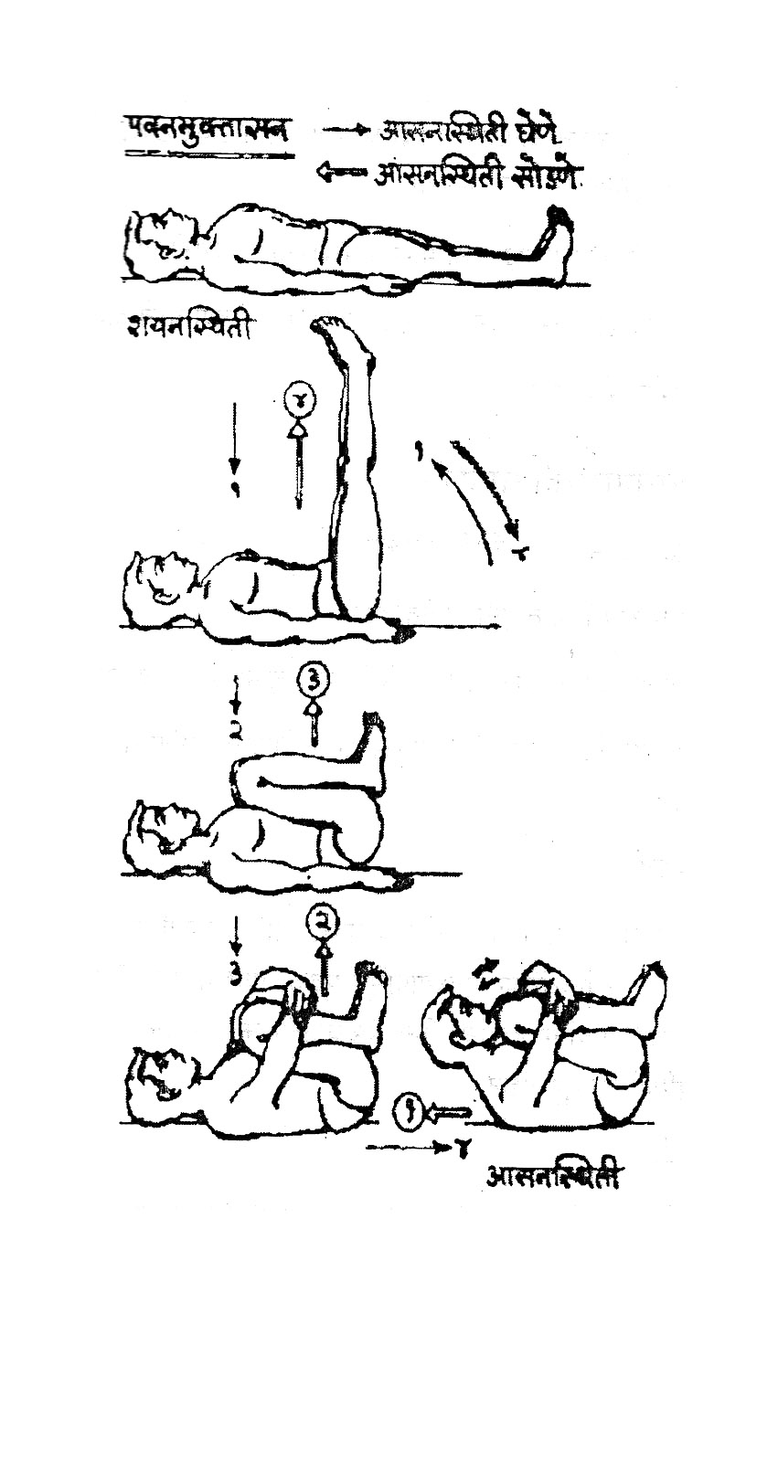
1) Exhale and inhaling, start raising both the legs and come to Dwipada Uttanpadasana Position.
2) Bend both the legs in the knees and keep the folds on the belly. Keep the knees and toes together.
3) Now keep the belly pressed to the thighs and clasp the folded legs with both the hands.

4) Now bending the neck, raise the head and fix the chin between the knees.

The Asana Position :
It is necessary to keep the knees and thighs pressed against the chest and belly in this asana. At the same time the calves should also be pressed against the thighs so that when the hands clasp the legs, the desired pressure can be had on the belly. The proper pressure on the concerned organs of the body gives the desired benefits.

Releasing The Asana Position :
1) Straighten the neck and bring the head on the floor.
2) Unfold the hands and bring them to their earlier position.
3) Inhaling, straighten both the legs and come to Dwipada Uttanpadasana Position.
4) Exhaling, slowly bring both the legs down and place them on the floor and take Supine Position.
Duration :
Generally it should be maintained for one minute. That way this Asana can be retained longer but that is not necessary.
Internal Effects :
Due to the nice and systematic pressure on the belly, the trapped gases in the large intestine are released. This improves the digestion system.
Precautions :
People who have had abdominal surgeries, or suffering from hernia and piles, etc. should perform this asana after consulting some yoga expert. Similarly, the pregnant women should not practice it.

SHAVASANA
Introduction :
The name of this asana sounds to be a highly perplexing and astonishing one. However, one need not be dismayed. This Asana implies a fixed and motionless position as that of a dead body i.e. a corpse. And hence, it got the name ‘Shavasana’ (corpse posture). Actually a corpse and this asana position stand poles apart, when seen in respect of their internal states of the body. This asana is chiefly meant for rest and relaxation. The moment the body gets tired, while doing asanas, one should immediately turn to Shavasana and get rid of the strain and fatigue.
Taking The Position:
Initial Position : Supine Position
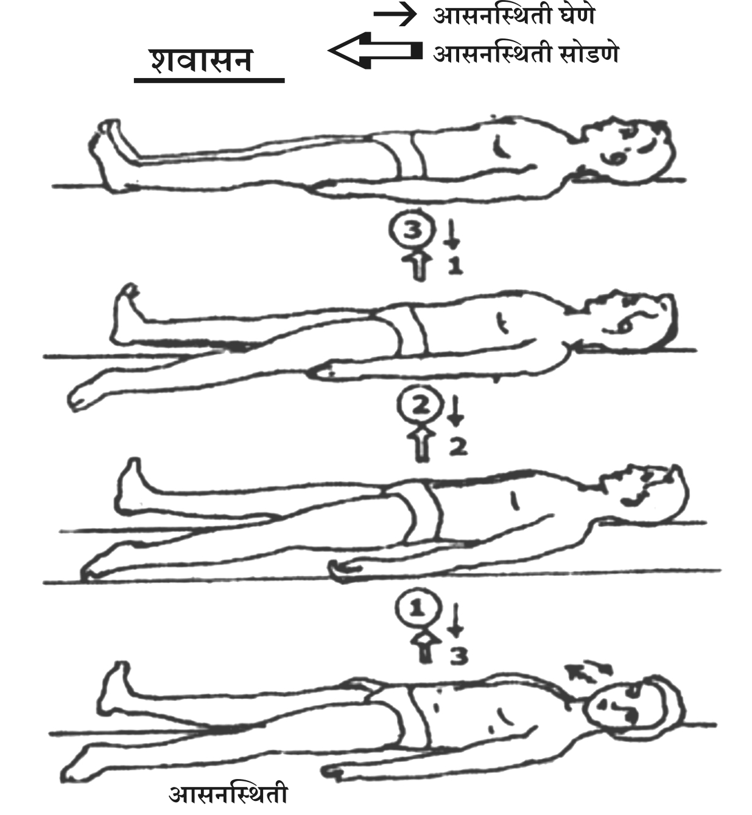
1) Spread both the legs and place them at the distance of one or one and half feet between the heels. Then keep the heels inside facing each other together and allow the toes to fall outside and relax them.

2) Take both the hands a little away, say 3 to 4 inches, from the body and relax them. Keep the palms facing the sky and the fingers half-closed, just relax them completely.

3) Turn the neck to any side and relax it. Further, relax the muscles of the face. Keep the eyes closed with ease and without pressure. Continue extremely slow breathing.

The Asana Position :
The asana outwardly looks extremely simple, but is highly difficult to practice. To keep the body in a corpse-like state is the external position and it is not so important. The important thing or success of this asana, lies in relaxing every muscle in the body. Or it can be said that the very aim of this asana is to relax each and every muscle in the body. And in order to reach or attain this aim, it becomes necessary to take the position in which one finds all the limbs of the body in a comfortable and soothing state. If one feels comfortable in supine position he should do Shavasana in that position. In every position of the body, there is always a kind of strain or pressure on every muscle which is called tone. Now the real aim of this Asana is to reduce this strain of the muscles and give them the real rest and relaxation. All the muscles cannot be relaxed immediately after taking the Shavasana Position. For this purpose, one has to relax all the muscles one by one with great deliberation. One has to pacify and relax the mind and free it from thoughts, ideas, worries, and so on. One has to think of all the muscles i.e., right from the muscles of the toes to those of the head and relax them. This process of relaxation should take place with the full knowledge of the mind, or rather under its supervision. It is very easy to contract a muscle, but it is very difficult to relax it. For this one has to make a lot of systematic efforts.
In this asana rest is meant for both the body and the mind, and that is even interconnected. If the mind is occupied by thoughts and worries, then the Shavasana is not successful, as the body would not have any relaxation. Therefore, one has to acquire the stability of mind along with the stability of body. After taking the position, first an attempt must be made to free the mind from all sorts of thoughts, and concentrate it on the body. Then concentrate on each section of the body and relax that area fully. This way after relaxing the whole body, turn the direction of the mind towards the breathing and concentrate the mind on it. However, do not allow the mind to control the breathing. On the contrary see that the breathing is getting extremely slow. The breathing will slow down in proportion to the relaxation of the muscles of the body. If the breathing is not very slow, one can take it that the desired relaxation of the muscles of the body has not taken place.
The backbone by nature has two curves in it. Consequently its lumber part just above the waist does not touch the floor along with the other organs of the body. But after a lot of practice of this asana even this part of the backbone also starts touching the floor. One has to try to acquire this state of the body. Similarly, the breathing should slow down so much that it almost comes to a halt. And this would be the ideal state of breathing. Thus finally the body is fully relaxed, the breathing at slowest rate, and the mind completely stable and quiet. This is the expected final position and state of Shavasana.
Releasing The Asana Position :
Since the whole body and the mind are in relaxed state in this asana, it should be released in stages. First, one should prepare one's mind for releasing the asana. Then all the muscles should be brought to their normal tone, and then after preparing first the mind, then the body, the asana is to be released as described:
1) Open the eyes and straighten the neck.
2) Get the hands beside and near the body.
3) Bring both the legs together and take the supine position.
Duration :
Since this Asana is meant for rest, its duration is not fixed. The only principle to remember is to do this asana when the body is tired and release it when the desired rest is had.
Internal Effects :
Right from the time of conception to the time of death, innumerable processes continue operating incessantly inside the human body. Even when the body looks externally quiet or asleep, its internal operations continue non-stop. Further, it can be said that the relaxation of the body depends upon the scale of slowness of these operations. Therefore, attempt is to be made to slow down the internal operations of the body in this asana.
Every activity inside the body needs oxygen and that is supplied through blood circulation. The increase in the speed of any inside activity requires more blood supply and this in turn is made by speedy blood circulation. For this the speed of the breathing is increased. Thus a whole vicious cycle sets in. In Shavasana, an attempt is made to slow down the speed of any such activities inside the body and thereby a new normal cycle is initiated. In this asana all internal operations greatly slow down, even come to a stand-still point. As a result of this, the breathing also slows down. This slowing process further influences the mental state. The mind is greatly pacified and freed from its activity. This state of mind further slows down breathing and the speed of the internal operations of the body. Finally, the whole body becomes completely relaxed, composed and motionless. This final position of the body gives the impression of a corpse. This relaxation and rest has a nice effect on the brain and improves its functioning. High Blood pressure comes down in this Asana. This is also useful to prevent and cure heart complaints.
Precautions :
As this is the asana for rest and relaxation, there is no reason to take care. However, while doing this asana, one should not sleep. This precaution is to be observed without fail.

* * *

